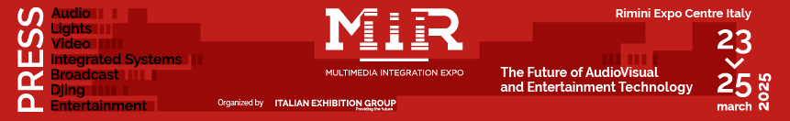

press release
(English translation)

RIMINI (ITALY), LET THE SHOW BEGIN: MIR LANDS ON SUNDAY.
THE FUTURE OF AUDIOVISUAL AND ENTERTAINMENT

- Opening conference featuring Luigi De Siervo, CEO of the Serie A Football League
- From Sunday to Tuesday, Rimini will once again be the go-to destination for Light, Sound, Visual, Integrated Systems, and Broadcast technologies.
- From the exciting new entry, The Corporate Communication Pavillion to live audio, visual, and lighting experiences, MIR Club for DJs and producers, featuring renowned console personalities

Rimini (Italy), 21 March 2025 – The countdown has begun for the opening of MIR - Multimedia Integration Expo, an event curated by Italian Exhibition Group (IEG) at Rimini Expo Centre, running from Sunday, March 23 to Tuesday, March 25. An event that's all about “The Future of Audiovisual and Entertainment Technology”, exploring the emerging technologies shaping the future of audiovisual and entertainment. Spread across 8 halls and over 40,000 square metres of exhibition space, with more than 200 exhibiting brands and over 50 conferences, masterclasses, and training courses on the agenda, MIR will bring together leading companies and professionals from the audio, video, lighting, and broadcasting system integrator sectors. This year’s edition is set to expand its boundaries to encompass the corporate, education, and retail sectors.

PRESIDING OVER THE INAUGURAL CONFERENCE, LUIGI DE SIERVO, CEO OF THE SERIE A FOOTBALL LEAGUE
On Sunday, March 23, at 11:30 am, following a warm welcome from IEG President Maurizio Ermeti, the inaugural event “The Evolutionary Path of Sports Content” will feature Luigi De Siervo, CEO of the Serie A Football League, in an interview with journalist and TV host, Valeria Ciardiello. The discussion will focus on the latest strategies for producing and distributing sports content, the impact of cutting-edge technologies, audience segmentation, and the challenges of digital monetisation. This event is part of the new Broadcast Production area, which aims to become the essential reference for anyone working in the audiovisual production industry and a true laboratory of the future for leading Italian media companies. The calendar also includes events featuring experts from Mediaset, Sky, Rai, and Sony, who will discuss successful strategies, investments, and the impact of new technologies on consumer patterns.

DISCOVERING THE LATEST WORKPLACE TECHNOLOGIES AT THE CORPORATE COMMUNICATION PAVILION
This year's edition marks a significant step forward, spotlighting integrated technologies and a multidisciplinary approach. In the new Corporate Communication Pavilion (Hall A4), visitors can explore innovative solutions for corporate communication, including displays, LED walls, BYOM systems, and videoconferencing platforms. Lastly, in collaboration with SIEC, a comprehensive range of tailored solutions will be presented, offering opportunities for updating and networking.

LIVE YOU PLAY: FOUR STAGES FOR LIVE, IMMERSIVE ROOMS, AND THE NEW SOUND POWER OUTDOORS
Among the event's long-standing attractions is Live You Play, featuring four stages where the public can experience live audio and video technologies. Immersive Rooms will also be available, offering a multidimensional audio experience. A new addition for 2025 is Sound Power, an outdoor area for live demonstrations of audio systems. On top of that, the Live Experience Area will showcase technological innovations through performances that reveal the technologies behind immersive experiences. One such example is the Black Box show, inviting professionals and aficionados to experiment with new ways of interacting with music and sound.

MIR CLUB, THE HOME OF DJ CULTURE
Now in its third edition, MIR CLUB has established itself as a leading event in the Italian electronic music scene, offering an experience that seamlessly blends training and technological innovation. The event boasts an experience area featuring the largest console exhibition ever seen in Italy. Among the highlights, Demolition Panel, offering young producers the chance to showcase their creations to a jury of industry experts. Scratch Village hosts a competition featuring top Italian DJs, while the DJ Mag Tech Clinic, led by Federico Doria, provides valuable technical advice to optimise equipment and prepare setups tailored to diverse needs, enriching the participants' skills. The show is expected to attract well-known faces and leading figures from the professional world, such as Albertino, Big Fish, Andro, Roberto Intrallazzi, Albert Marzinotto, Giacomo Maiolini, Sergio Cerruti, Dj Skizo, Dj Aladyn, and Master Freez.

TALKS AND MASTERCLASSES: TOP-NOTCH TRAINING FOR THE PROFESSIONALS OF TOMORROW
Training will be a cornerstone in the upcoming edition of MIR. The Masterclasses, tailored for live production and lighting technicians, will provide opportunities for professional development and networking with top professionals. Among the main events, the show design behind the scenes of Vasco Live San Siro 2024 with Pepsy Romanoff, director and creative director. What’s more, the LD@work series of meetings, curated by Giovanni Pinna, will delve into the new frontiers of integrated technological applications, opening up innovative scenarios that extend well beyond the live show.
ABOUT MIR 2025
Date: 23/25 March 2025; event type: international expo; organiser: Italian Exhibition Group S.p.A.; recurrence: annual; edition: 9th; open to: professional operators and general public; info: www.mirtechexpo.com

PRESS CONTACT ITALIAN EXHIBITION GROUP
head of corporate communication & media relation: Elisabetta Vitali
press office manager: Marco Forcellini, Pier Francesco Bellini | press office coordinator: Luca Paganin | international press office coordinator: Silvia Giorgi | press office specialist: Mirko Malgieri; Nicoletta Evangelisti | media@iegexpo.it

MEDIA AGENCY MIR
Naper Multimedia| Zoe Perna | T. +39 02 97699600 | zoe.perna@napermultimedia.it | staff@napermultimedia.it

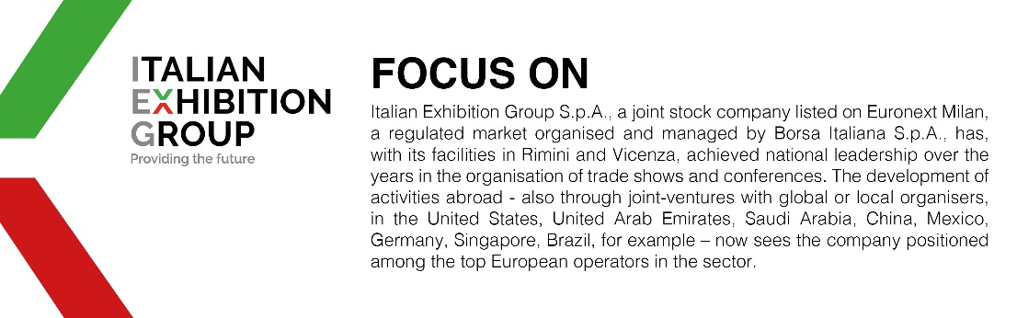

This press release contains forecast elements and estimates that reflect the management´s current opinions (´forward-looking statements´), particularly regarding future management performance, realization of investments, cash flow trends and the evolution of the financial structure. For their very nature, forward-looking statements have a component of risk and uncertainty, as they depend on the occurrence of future events. The effective results may differ (even significantly) from those announced, due to numerous factors, including, only by way of example: food service market and tourist flow trends in Italy, gold and jewellery market trends, green economy market trends; the evolution of raw material prices; general macroeconomic conditions; geopolitical factors and evolutions in the legislative framework. Moreover, the information contained in this release, does not claim to be complete, and has not been verified by independent third parties. Forecasts, estimates and objectives contained herein are based on the information available to the Company as at the date of this release.

